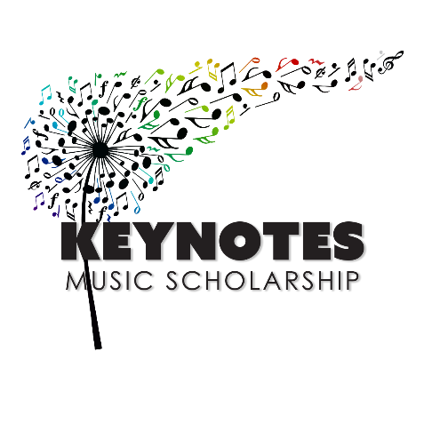

STUDENT APPLICATION FOR AUDITION
For more information, please call Mrs. Kvederis, (412-892-8395)
Student Information

Student Name: |  |  | Phone #:
Email:
High School:
Parent/Guardian Information

Name 1: |  | Phone #:
Home Address:
Name 2:  (if applicable) |  | Phone #:  (if applicable)
Home Address:
(if applicable)
Schools & Programs Attended
List school names, degrees and dates, including special programs, workshops, etc

1.
2.
3.
4.
Present School: |  |  | School in Fall:
Level in Fall ’22: | (circle one) Freshman Sophomore Junior Senior Graduate
Voice (Soprano, Tenor, etc.) or Instrument:
Would you like judges critiques? |  | (circle one) Yes No
If yes, bring a self-addressed stamped envelope the day of the competition
STUDENT APPLICATION FOR AUDITION
Applications must be postmarked by April 30, 2022. We strongly urge you to return the complete application package as early as possible, as we operate on a first come, first serve basis.
To prepare for the audition:
- You are required to perform one selection representative of each of these periods: Baroque (1600-1750), Classical (1750-1820), Romantic (1820-1920), and 20th century (1900-Present).
- Vocalists must include at least 2 different foreign language selections.
- Applicants must provide their own accompanist.
- Each applicant will be allotted fifteen minutes for the audition.
- Memorization is preferred for the audition selections.

Period | Selection | Composer
Baroque
(1600-1750)
Classical
(1750-1820)
Romantic
(1820-1920)
20th century
(1900-Present)

First time applicants: Send completed application form, proof of age, residency, resume, and teachers’ recommendation along with $30 Non- refundable registration fee, checks made payable to Keynotes.
Previous applicants need only forward a completed application form and
$30 registration fee, checks made payable to Keynotes.
Mail applications to: Toni Kvederis, 1500 Cochran Rd. Apt.909, Pittsburgh, PA, 15243
How did you learn of our competition?

Applicant Signature:

